

UNDERGRADUATE PROJECT(SLIIT)

Reflective Report

Mobile Application to Improve Mental Health of Persons with Dementia

BSc (Hons) Computer Science & Software Engineering

University of Bedfordshire

**Nishshanka Nimesh Mendis**

**2012430**

Supervisor: Mr. Vibhavi Attigala

2021 March

Table of Contents

01. Introduction 1

01.1 Overview of the Reflective Report 1

01.2 Project Background 1

01.3 Motivation 1

02. Self-management 2

02.1 Topic selected and technology used 2

02.2 Supervisor Feedback 2

03. Reflection 3

03.1 Introduction 3

03.2 Current Progress 3

03.3 Time Management 5

03.4 Future Work 5

03.5 Lessons learned 5

03.6 Recommendations for future Researchers 6

03.7 Conclusion 6

04. Detailed Thesis content 7

# Introduction

## Overview of the Reflective Report

The report structure includes five sections. The first section will explore the structure of this report, a short project background, and also the motivation behind selecting the proposed project. The second chapter contains the outline of the subject selection and also the technologies which is the researcher got used in this project and also it will explain how the researcher conduct research and literature review. After that, it will explain how the applying will test it on a selected group of individuals. Moreover, the second chapter also will contain a self-reflection. The third section of this report contains the reflection of the project’s current status in correlation to the set milestones at the start of the project including; how the time was managed, the readiness to organize for any outcome, and therefore the strategies put in place to keep the project on the right track. The fourth and final chapter of this document will include a close breakdown of the thesis contents which might be submitted with the whole system.

## Project Background

The proposed system is a smartphone platform for people with dementia, with the aim of providing a modern alternative with a mobile application. The project investigates brain-training games and relaxing music. Users can save their personal information by creating a profile. Users may also check their contact information. Since it is a smartphone device, users can quickly access the system by inserting their user email and password. The proposed framework includes an Artificial Intelligent chatbot to help the user with their everyday tasks.

## Motivation

It was intimidating to have only one week to come up with an appropriate research topic for an undergraduate degree program. And that could not be modified later. As a result, I agreed to collaborate with my supervisor to choose a suitable subject. The chosen subject is relevant to all family members, colleagues, and caregivers of People with dementia. Dealing for dementia patients can be a challenging job for caregivers at times. What if the caregivers use cutting-edge technologies to look after their loved ones? To do so, we will need an appropriate application tool to administer their daily activities.

Since this century people have so much attract to the technology this have an impact on most of our daily tasks. Further proposed system provides user activities which is helpful for brain recoveries by identifying and recognizing colours objects. The researcher hopes this will helpful for their brain improvement and stability.

# Self-management

## Topic selected and technology used

In the majority of countries around the world, the occurrence of dementia in humans can be a common concern. Many factors may contribute to this, including maturation, obesity, hypertension, and so on. Since the problem seems to be spreading across the globe, it requires immediate intervention and a solution. Since undertaking extensive communications analysis and conducting a literature review, the situation seemed to be worsening by the day. This researcher suggested a smartphone device to assist people with dementia as a solution.

Android Studio is the production site for the proposed system since it is a smartphone application. Since Java is a programming language, it is used. The database will be implemented using Firebase.

## Supervisor Feedback

The project's flow has been made pleasant and seamless thanks to supervisor input. The supervision of my supervisor proved to be a major asset during my initial study phase. I was able to fulfil my time targets due to the suggestions I got from the comments. Just had a small research concept in the first meeting with the supervisor, which grew into a near research idea input received.

The supervisor's first aim was to identify the causes that induce dementia through going at previously written research papers. In addition, the supervisor set a goal to read relevant papers on dementia and devise a strategy for developing smartphone apps for people with dementia. In addition, the supervisor set a goal to gather and read life experiences from family members, caregivers, and colleagues who have worked with people who have dementia. The supervisor's next recommendation was to use a questionnaire to perform marketing analysis. The researcher administered two independent questionnaires, one for doctors and the other for relatives, caretakers, and friends of people with dementia, based on the supervisor's ideas.

Because of the Covid 19 epidemic, publicity study for doctors did not generate adequate responses. By gathering suggestions from the doctors, the researcher was able to improve the appliance. The questionnaire that was issued to the relatives elicited responses from 40 people. The data was then analysed using the IPSS method according to the supervisor's instructions. The next step was to complete the system's functions. The mobile application was to be implemented with the help of an Artificial Intelligent chatbot, as discussed with the supervisor. After consulting with my supervisor, the researcher chose to include a feature that allows the chatbot to use Google search results. My supervisor recommended that I use the Artificial Intelligence Chatbot as a test part in my research study.

Initially, the study framework was to come up with a look concept. Then, in the chosen area, perform a literature review analysis. Then, through marketing analysis, evoking suggestions and determining the solution to the problem at hand. The solution must then be applied and checked on a particular set of people.

Since the study addresses a particular issue in culture, it brings importance to the society. As a result, the response is also important to the study discussion.

# Reflection

## Introduction

This section will document the developer’s reflection report upon the initiation stages of the project the process followed during the planning, designing and developing phase of the proposed system. Furthermore, it will describe the progress and the current standing of the application in terms of development. This section also describes the personal growth and experience of the researcher throughout the project.

## Current Progress

Currently research documentation is almost done. Project proposal and contextual report is completed. What is left of documentation is the final thesis. All the facts, details and diagrams needed for the final thesis are in the place.

The proposed system-built interface was not appropriate for the subject, according to feedback from my peers and mentor. Often, the colour scheme is inappropriate for the application. As a result, the researcher agreed to ask his supervisor for guidance and to change the entire User Interfaces once again.

As for the implementation of the system, researcher has started implementing the system. Altogether there are four main functions to be implemented.

* Dashboard
* Memory recall activity
* Recognizing objects activity
* AI Chatbot

The memory recall and object recognition activity have been fully developed and are ready for research. The Identifying Object operation allowed the user to identify the colour generated by the device. A memory recall task was introduced in which the user had to recognize items in a given time and then pick boxes that were appeared objects in a given time countdown after they had vanishing. Before implementing the memory recall activity, I have researched how to do this activity in users (person with Dementia) side. Since I have done the literature review, I have found one application which is used same activity using comparing pictures. It is easy to grab the users’ mind because every person can grab attractive things very quickly and they can even remember where it was. I have decided not to use pictures, instead of using pictures I have used letter capital ‘O’. Because of this user needs to pay some extra attention for the activity. After completing each level, the difficulty level is getting high user needs to have concentration to complete the difficult level.

As shown in the below figure1. A code segment which is used to implementing the recognize colours activity in a given time period. Figure2. A code which is used to implementing the recognize object in a given period of time. Following code segments might get change in the future for further enhancement and modifications.

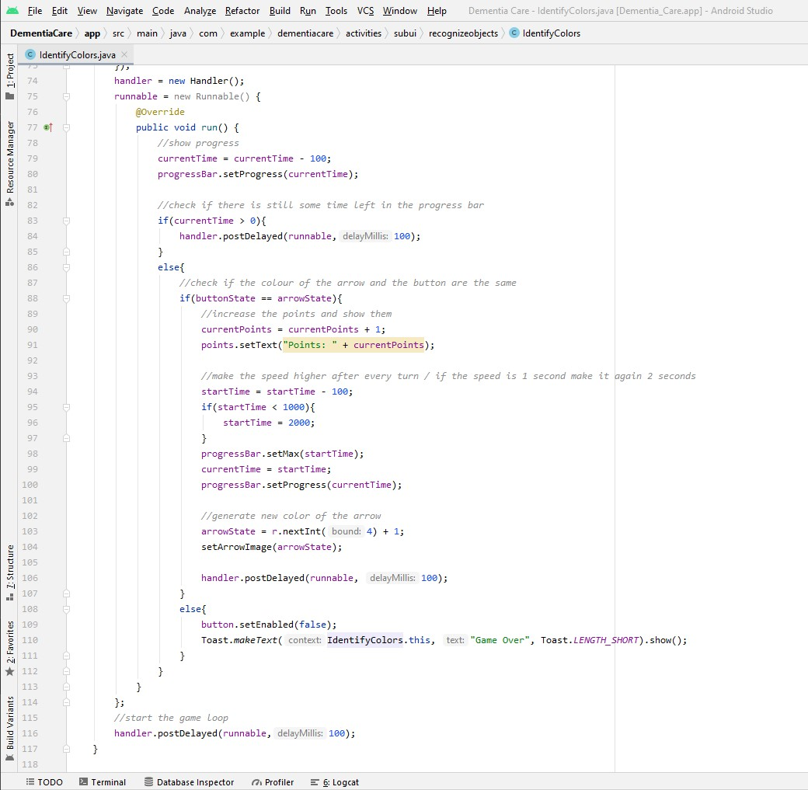

Figure 1 - Code segment for recognize colours activity

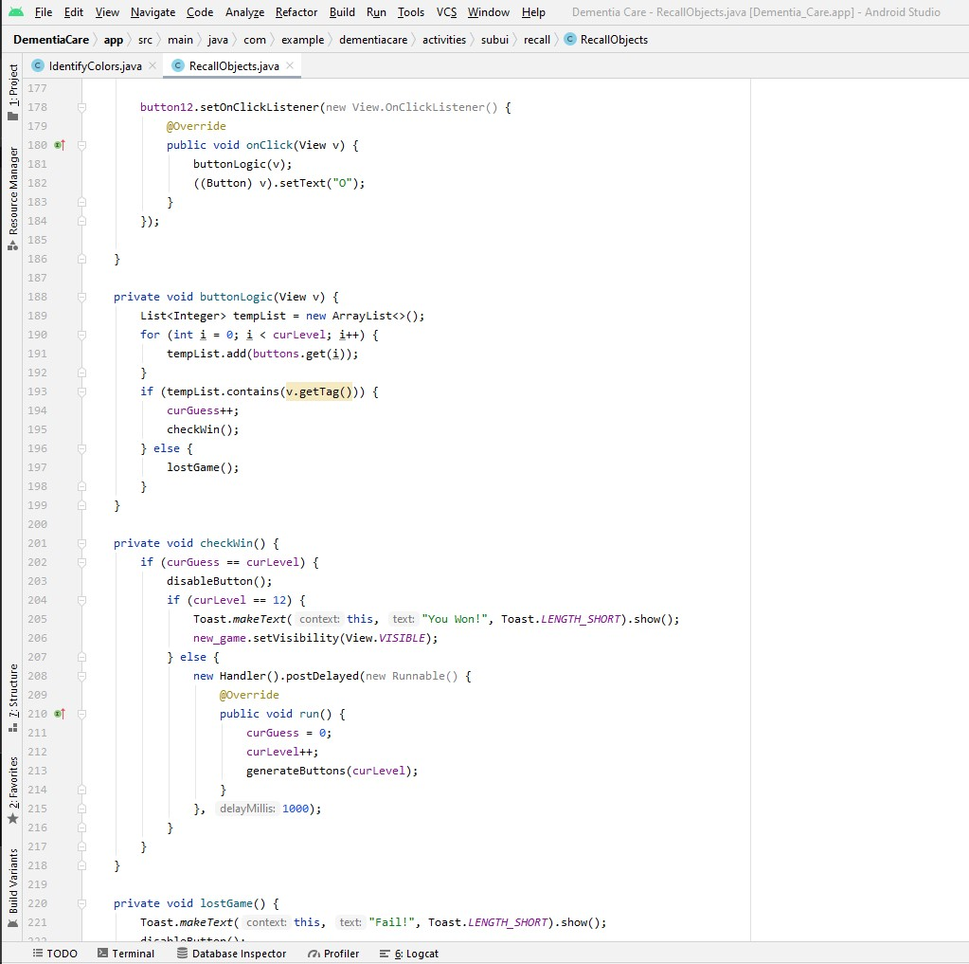

Figure 2 - Code segment for recognize object activity

## Time Management

During in the Software Development Life Cycle, maximizing time and ensuring the potential to perform within a specified timeline may be a critical factor to consider and prioritize on any given project. The time allotted for the project should be used wisely to ensure that all of the relevant activities are completed within the time frame. Due to a variety of factors, this project, which was given a time frame of approximately 6 months and is carried out by one researcher, has found it difficult to stay on track as per the initial Gantt Chart.

According to the Gantt chart, the project should be in its fourth sprint and nearing completion of the event; however, for a variety of reasons, it is still in sprint two, and the researcher has recently decided to incorporate an AI chatbot feature. To ensure that the project's reach is completed within the remaining timeline of roughly 10 weeks, a considerable amount of effort is needed to restore momentum. The researcher has reorganized and set a timeline to sort things out, resulting in improved efficiency and the reduction of procrastination. Due to the Covid-19 Pandemic, it was impossible to keep track of time and get support from other people face to face. Working at home has a significant effect on and reduction in productivity.

As I previously said, the researchers recently decided to include an AI component in the proposed application. The Gantt charts are not always accurate for time management because adding a new element, such as sprint growth, requires the researcher to re-adjust the time frame. The best way to prevent this is to complete the final specifications before starting to implement the method.

Also, I mentioned in earlier paragraphs in section 04.2 that the researcher needs to change the whole colour themes once again according to suitable manner. I need to spend some time to redesign all the user interfaces once again.

## Future Work

From now on, the primary emphasis would be on the execution of the system's completed features. Once the dashboard has been built, memory recall activity and object recognition activity must be thoroughly checked before being released to the customers. At the same time, I need to make some improvements to the Artificial Intelligence chatbot, alert from reminders, and to-do list in the app. In addition, the researcher would change the whole user interface style to one that is acceptable for the user. By the first week of April, complete the Dementia Care mobile application's deployment so that testing can begin. The Gantt chart mobile application will be finished by the end of April due to updates, and the remaining time will be allocated to the testing process. For the testing, manual testing will be carried out for every functions and database. Testing will continue until the end of the second week in May. After finishing the system, the necessary changes and bug corrections will be made to the system's testing and it will be released as a new version. By the end of the third week of May, dementia care will be complete, and end users will be able to access it in real time. Along with the scheme, an implementation must focus on the final Thesis paper, since it is the last piece of paperwork and the research must be completed.

## Lessons learned

It is important to perform a literature review and a market research on the selected subject prior to introducing the method. However, based on past practice, it is more important to undertake adequate marketing research in order to have a clear view of the research field. I was able to get a correct view of the matter and the response needed because I was prepared to do research with the right group of questioners and collect input from 40 members of the family of people with dementia. Furthermore, since I was prepared to complete system functions from the outset, a clear understanding of the final result was obtained right away.

The main disadvantage was that the framework development finished way too late. It is best to launch the framework development alongside the project report as a best practice. When the project is on a fast timetable, it will save time for a much smoother testing phase.

## Recommendations for future Researchers

Since the developed system uses chatbots with advanced artificial intelligence techniques, the current framework is different from other current implementations. The researcher hopes that the proposed application will assist people in caring for their loved ones.

## Conclusion

Finally, I realized that, while the opportunity to be creative and think beyond out the box was critical to the research success, the three constraints of 'Context', 'Time Duration', and 'Benefit' were also essential factors. Except the other factors 'Time Duration' is normally the most difficult and most important factor which is affected to the project which all the researchers should consider it seriously.

# Detailed Thesis content

* Title page
* Abstract
  + This part will include a summary of the projects
* Acknowledgement
  + Vote of thanks for each and every individual person who helped me in each and every way in guiding to win all the challenges and obstacles in the completion of the project
* Dedication
  + To offer warmest gratefulness to whoever need to be honoured.
* Table of contents
* List of figures
* List of tables

**Chapter One: Introduction**

* 1. Background of the project

This part includes the background story of the project. This will include how the idea was developed to conduct a research on the selected topic.

* 1. Project aims and objectives

Aims and objectives that I wish to achieve at the end of the project and what are the possible outcomes in doing so.

* 1. Description of the artefact

Detailed description of the final end product will be discussed in the section

* 1. Report structure

Detailed idea about the chapters in the final thesis report

**Chapter Two: Literature Review / Market Research**

2.1. Literature Review

2.1.1 Introduction

This section will include an introduction to the literature review

2.1.2 Recovery memory using mobile application

This section will explain how a mobile application will helpful to recover memory

2.1.3 Existing healthcare applications for Dementia

This section will include all the existing applications available in the mobile application stores

2.1.4 Conclusion

This section will include the final conclusion of the literature review

2.2. Market Research

This section will provide you information regarding how the market research carried out before implementing the proposed system.

**Chapter Three: Methodology**

3.1. Methodology

Methodology selected for the implementation of the project will be discussed in this section.

3.2. Requirement Gathering

In this section will provide how primary and secondary data gathered

3.3. Design and Development

Design phase and the implementation phase of the project will be including in this section with the relevant system diagrams.

3.4. Testing and Evaluation

Performance of the implemented product will be tested and highly evaluated in this section

**Chapter Four: Results and Discussion**

All the developed functions will be discussed in detail in this section

* AI Chatbot
* To-do list
* Reminders
* Login and Registration
* Dashboard
* Memory recall activity
* Recognizing object activity

**Chapter Five: Evaluation**

Critically evaluation of the developed system will be done in this section

**Chapter Six: Conclusion**

6.1. Benefits of the project

Benefits earned by the developed project will be discussed in this part.

6.2. Limitations of the project

Flaws or shortcomings due to the mistakes in the methodology will be discussed in this section.

6.3. Future work and recommendation

Proposed other methods in developing the implemented system and other new features that can be added will be mentioned in this section which gives a head start for the future researchers.

**Chapter Seven: References**

**Chapter Eight: Appendices**